 |  |  |  |  | 1st |  | 2nd | 3rd |  | OT1 |  | OT2 |  |  | SO |  | TOTAL |  | TIMEOUTS  REGULATION |  | TIMEOUTS  OVERTIME
 | Media Timeouts |  |  |  | ‚ƒ |  | ‚ƒ | ‚ƒ
^{V} | Medfield College |  |  |  |  |  |  |  |  |  |  |  |  |  |  |  |  |  |  |  | 
^{H} | Tate University |  |  |  |  |  |  |  |  |  |  |  |  |  |  |  |  |  |  |  | 
SHOTS ON GOAL
^{V} | Medfield College
^{H} | Tate University
GOALS
Medfield College Lions |  |  |  |  |  |  |  |  |  |  |  |  | Tate University Warriors
No |  | Per | Type | Scorer |  | Assists |  |  | TOG |  |  |  | No | Per |  | Type |  | Scorer |  | Assists |  | TOG
1 |  |  |  |  |  |  |  |  |  |  |  |  | 1
2 |  |  |  |  |  |  |  |  |  |  |  |  | 2
3 |  |  |  |  |  |  |  |  |  |  |  |  | 3
4 |  |  |  |  |  |  |  |  |  |  |  |  | 4
5 |  |  |  |  |  |  |  |  |  |  |  |  | 5
6 |  |  |  |  |  |  |  |  |  |  |  |  | 6
7 |  |  |  |  |  |  |  |  |  |  |  |  | 7
8 |  |  |  |  |  |  |  |  |  |  |  |  | 8
9 |  |  |  |  |  |  |  |  |  |  |  |  | 9
10 |  |  |  |  |  |  |  |  |  |  |  |  | 10
11 |  |  |  |  |  |  |  |  |  |  |  |  | 11
PENALTIES
Medfield College Lions |  |  |  |  |  |  |  |  |  |  |  |  | Tate University Warriors
No |  | Per | Player | Length |  | Type |  |  | TOP |  |  |  | No | Per |  | Player |  | Length |  | Type |  | TOP
1 |  |  |  |  |  |  |  |  |  |  |  |  | 1
2 |  |  |  |  |  |  |  |  |  |  |  |  | 2
3 |  |  |  |  |  |  |  |  |  |  |  |  | 3
4 |  |  | 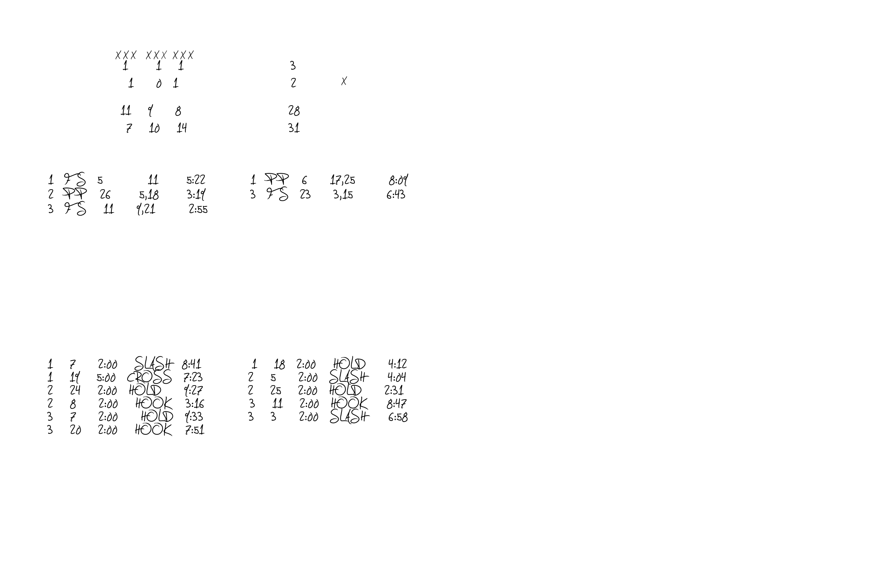 |  |  |  |  |  |  |  |  |  | 4
5 |  |  |  |  |  |  |  |  |  |  |  |  | 5
6 |  |  |  |  |  |  |  |  |  |  |  |  | 6
7 |  |  |  |  |  |  |  |  |  |  |  |  | 7
8 |  |  |  |  |  |  |  |  |  |  |  |  | 8
9 |  |  |  |  |  |  |  |  |  |  |  |  | 9
10 |  |  |  |  |  |  |  |  |  |  |  |  | 10
11 |  |  |  |  |  |  |  |  |  |  |  |  | 11
12 |  |  |  |  |  |  |  |  |  |  |  |  | 12
13 |  |  |  |  |  |  |  |  |  |  |  |  | 13
14 |  |  |  |  |  |  |  |  |  |  |  |  | 14

ROSTERS
Medfield College Lions |  |  |  | Tate University Warriors
## | PLAYER | GOALS |  | ## | PLAYER | GOALS
0 | Cam Welty | 0 |  | 00 | Austin Mitchell | 0
1 | Trevor Peterson | 0 |  | 1 | Nicklas Rulle | 0
2 | Fredy Mata | 2 |  | 2 | Rushoy Brown | 8
3 | Juan Alejandre | 0 |  | 3 | Thomas M'Barek | 4
4 | Josh Marquez | 9 |  | 4 | Vlad Jandric | 0
5 | Jacob Penner | 15 |  | 5 | Antonio Burgoa | 0
6 | Julio Varela | 6 |  | 6 | Zack Kluever | 2
7 | Luis Lopez | 3 |  | 7 | Lawrence Karpeh | 1
8 | Walmer Martinez | 0 |  | 8 | Stephen Milhoan | 16
9 | Steve Lopez | 2 |  | 9 | Noah Pio | 7
10 | Adrian Rebollar | 8 |  | 10 | Gianluca DiFranco | 3
11 | Harry Barba | 5 |  | 11 | Ben Hryszko | 1
12 | Rudy Pedroza | 11 |  | 14 | Jacob Lynn | 0
14 | Pedro Hernandez | 4 |  | 15 | Jannis Schmidt | 10
15 | Miles Ramos | 4 |  | 16 | Stjepan Mijic-Barisic | 0
16 | Justin LaPerle | 0 |  | 17 | Hayden Parente | 2
17 | Antonio Ordonez | 1 |  | 18 | Tommy Paltani | 4
18 | Steven Moreno | 0 |  | 19 | Gabriel Pewu | 1
19 | Adrian Ortiz | 2 |  | 20 | Saahb Kular | 1
20 | Matthew Lee | 9 |  | 21 | Thomas Bielanski | 0
21 | Luis Mendoza | 6 |  | 22 | Ivan Babic | 0
23 | Jordan Sime | 1 |  | 23 | Colin Kane | 13
24 | Raul Magos | 0 |  | 24 | Brandon George | 0
25 | Robert Rodriguez | 0 |  | 25 | Keagan Brown | 1
26 | Brad Moorehouse | 2 |  | 30 | Dan Manolache | 2
27 | George Gonzalez | 3 |  | 31 | Ryan Kolonick | 6
28 | Tanner Ruddy | 12 |  | 32 | Skylar Jeppesen | 8

