Starters |  | 1 | 2 | 3 | 4 | 5 | 6 | 7 | 8 | 9 | 10 |  | Starters |  | 1 | 2 | 3 | 4 | 5 | 6 | 7 | 8 | 9 | 10
1 |  |  |  |  |  |  |  |  |  |  |  |  | 1
2 |  |  |  |  |  |  |  |  |  |  |  |  | 2
3 |  |  |  |  |  |  |  |  |  |  |  |  | 3
4 |  |  |  |  |  |  |  |  |  |  |  |  | 4
5 |  |  |  |  |  |  |  |  |  |  |  |  | 5
6 |  |  |  |  |  |  |  |  |  |  |  |  | 6
7 |  |  |  |  |  |  | 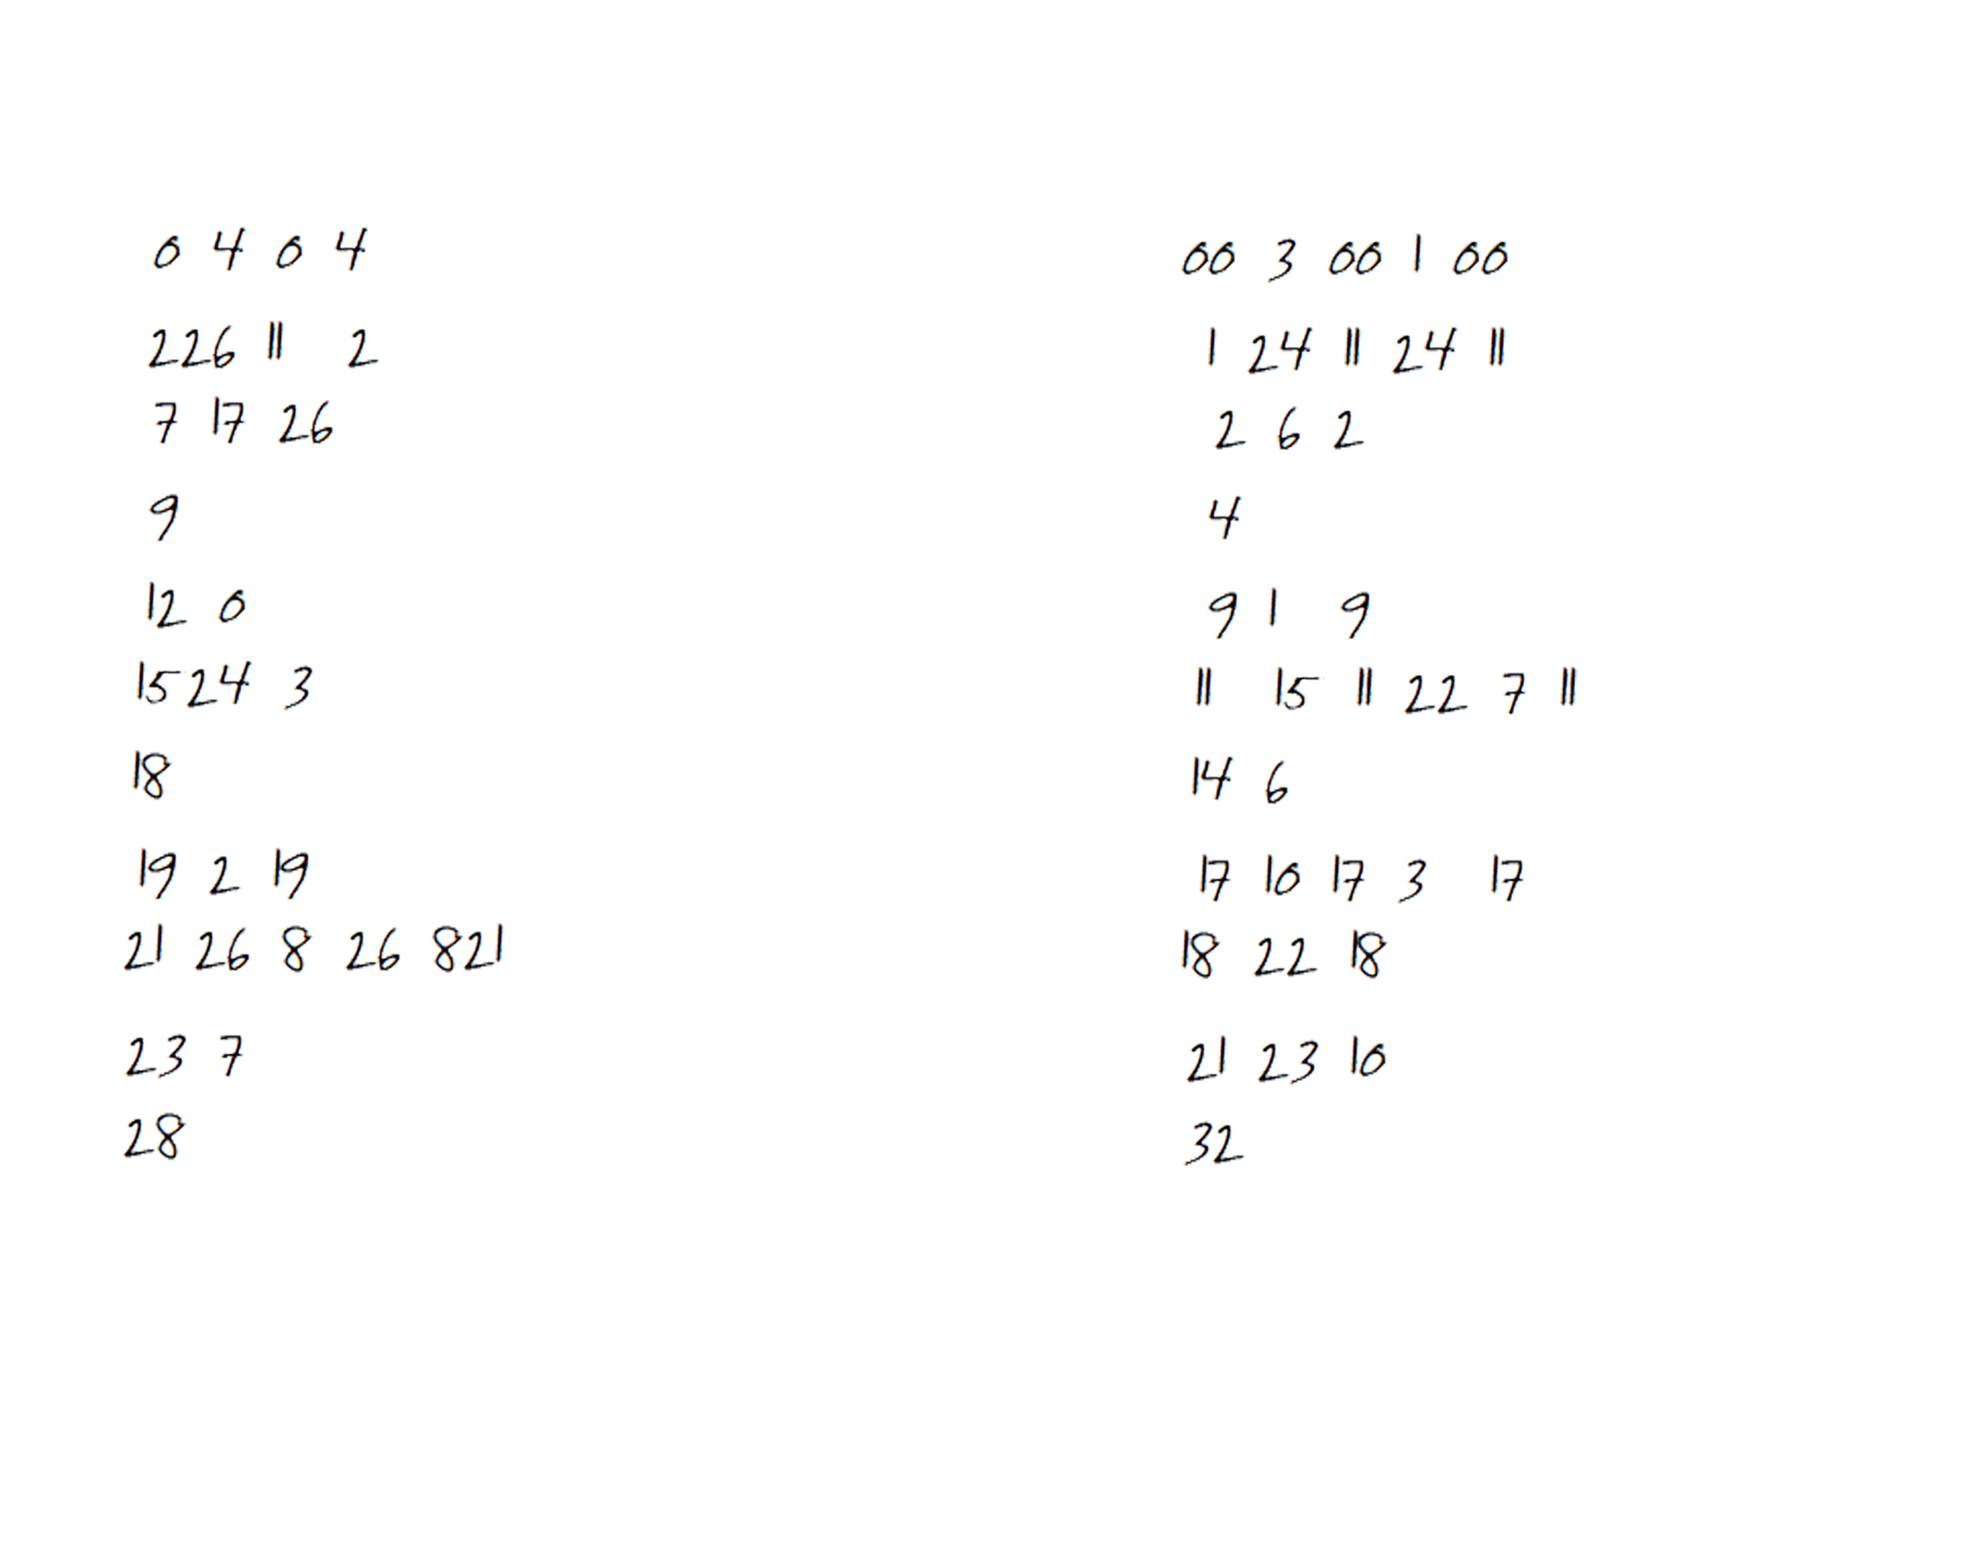 |  |  |  |  |  | 7
8 |  |  |  |  |  |  |  |  |  |  |  |  | 8
9 |  |  |  |  |  |  |  |  |  |  |  |  | 9
10 |  |  |  |  |  |  |  |  |  |  |  |  | 10
GK |  |  |  |  |  |  |  |  |  |  |  |  | GK

