 |  |  |  | 1 | 2 | 3 |  | 4 |  | 5 |  | 6 |  | 7/7 |  | 8 |  |  | 9 |  | 10 |  | TOTAL
^{V} | Medfield Little League
^{H} | Tate Little League
Top of Inning (VISITORS) |  |  |  | Medfield Little League
BO | ## | PO | PLAYER |  |  |  | 1 |  | 2 |  | 3 |  | 4 |  | 5 |  | 6 | 7/7 |  | 8 |  | 9 |  | 10
1
2
3
4
5
6
7
8
9
10
RESERVES |  |  |  |  |  |  | Notes/Special
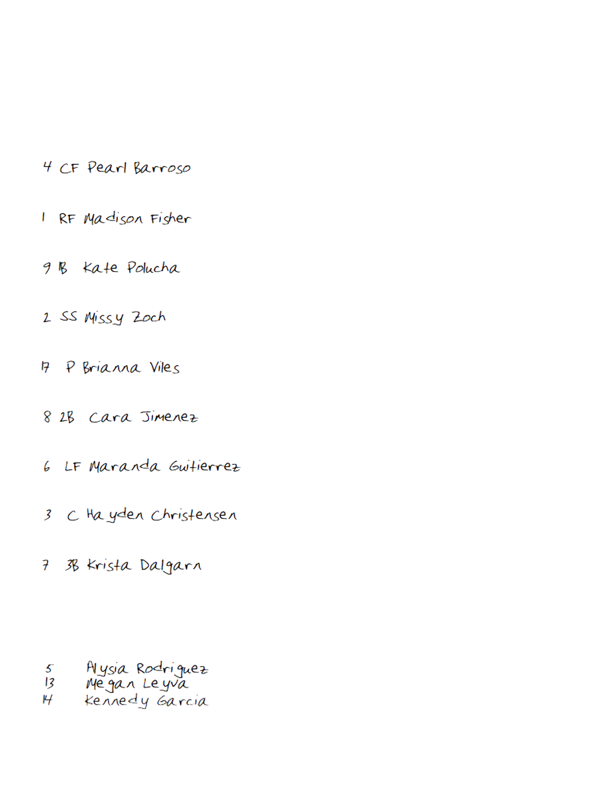

Bottom of Inning (HOME) |  |  |  | Tate Little League
BO | ## | PO | PLAYER |  | 1 | 2 | 3 | 4 | 5 | 6 | 7/7 | 8 | 9 | 10
1
2
3
4
5
6
7
8
9
10
RESERVES |  |  |  |  | Notes/Special
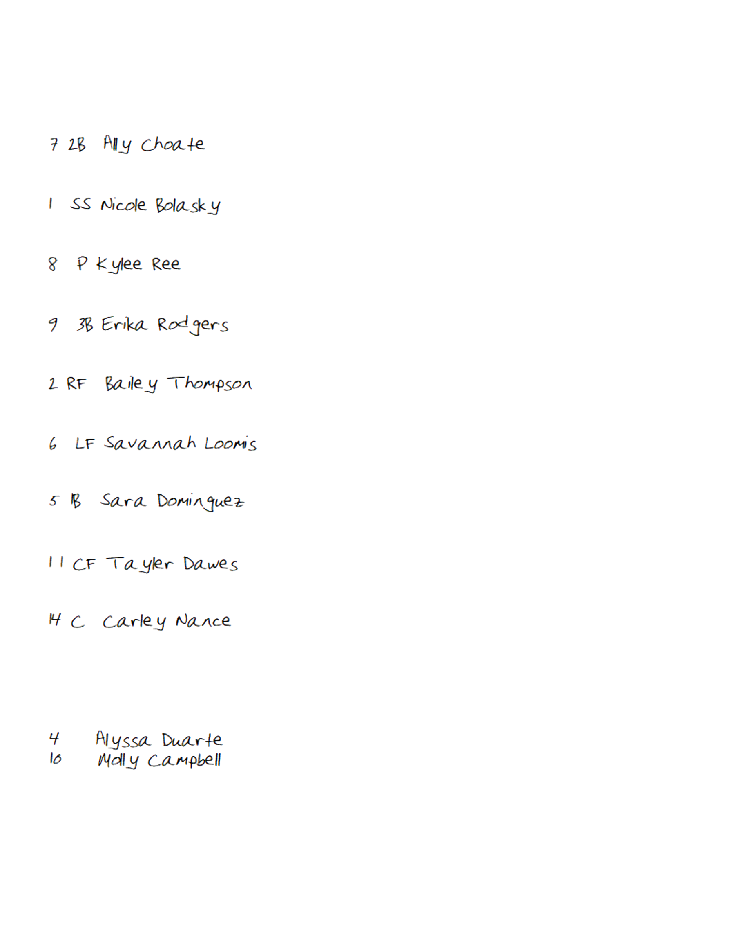
Game Notes:

