 |  | 1 | 2 | 3 | 4 | 5 | 6 | 7/7 | 8 | 9 | 10 | TOTAL
^{V}
^{H}
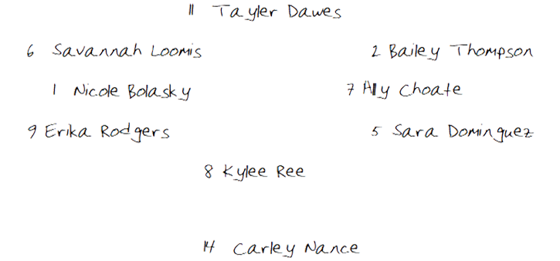
CF

Top of Inning (DEFENSE)

Top of Inning (OFFENSE)
BO | ## | PO | PLAYER |  | 1 | 2 | 3 | 4 | 5 | 6 | 7/7 | 8 | 9 | 10
1
2
3
4
5
6
7
8
9
10
Reserves |  |  |  |  | Notes/Special
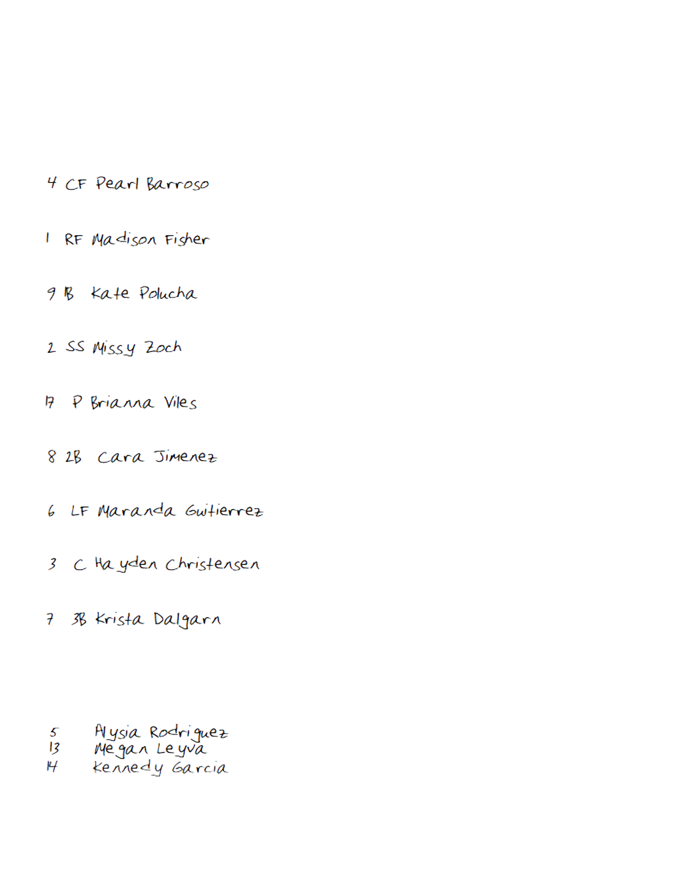
C

PITCHER

1B

3B

2B

SS

LF

RF

Bottom of Inning (DEFENSE)
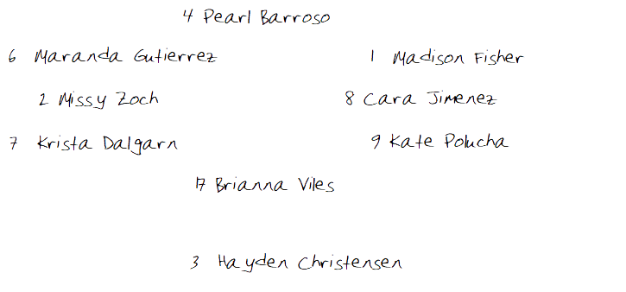
C

PITCHER

1B

3B

2B

SS

CF

RF

LF

Bottom of Inning (OFFENSE)
BO | ## | PO | PLAYER |  | 1 | 2 | 3 | 4 | 5 | 6 | 7/7 | 8 | 9 | 10
1
2
 |  |  | 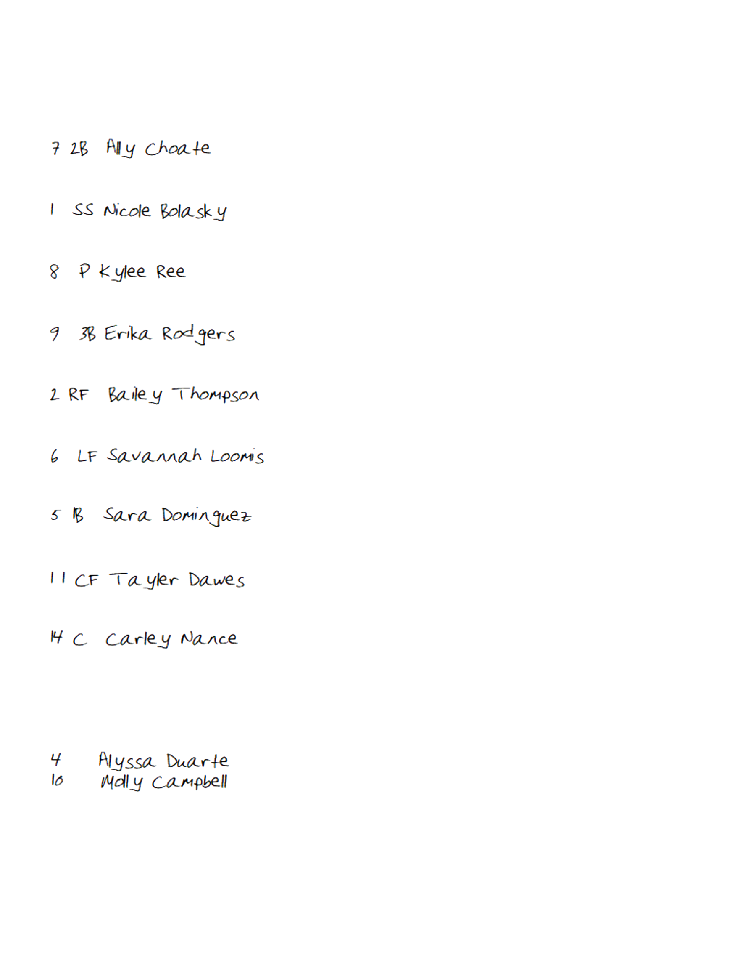
3
4
5
6
7
8
9
10
Reserves |  |  |  |  | Notes/Special

Game Notes:

