 |  | 1 | 2 | 3 | 4 | 5 | 6 | 7 | 8 | 9 | 10 | TOTAL
^{V} | Medfield College
^{H} | Tate University
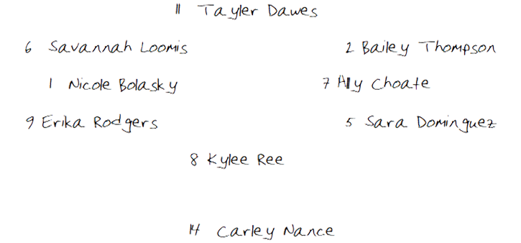
CF

Top of Inning (DEFENSE) | Tate University Warriors

Top of Inning (OFFENSE) |  |  |  | Medfield College Lions
BO | ## | PO | PLAYER |  | 1 | 2 | 3 | 4 | 5 | 6 | 7 | 8 | 9 | 10
1
2
3
4
5
6
7
8
9
FLEX |  |  |  |  | Notes/Special
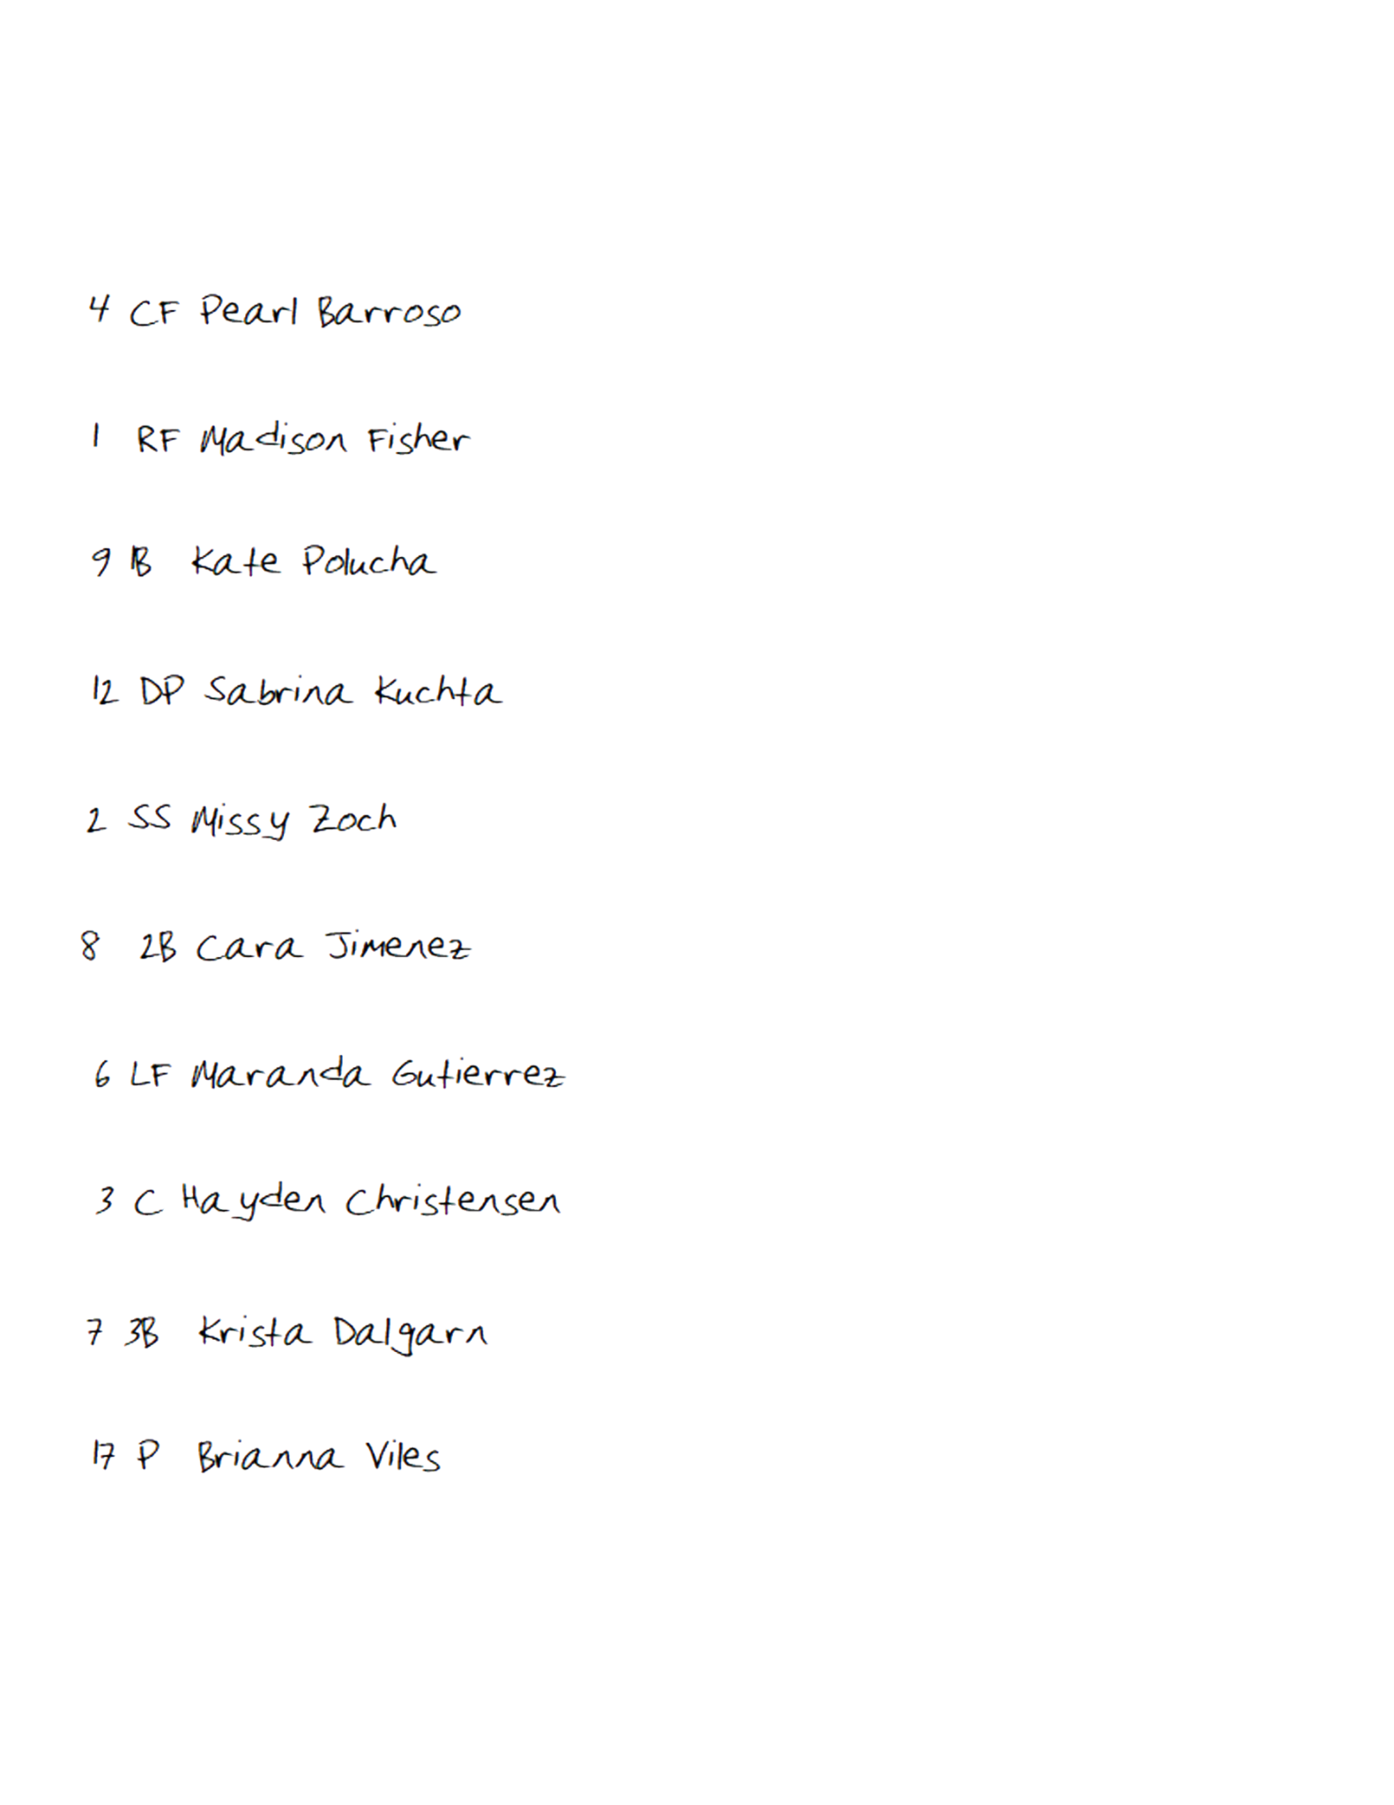
C

PITCHER

1B

3B

2B

SS

LF

RF

Bottom of Inning (DEFENSE) | Medfield College Lions
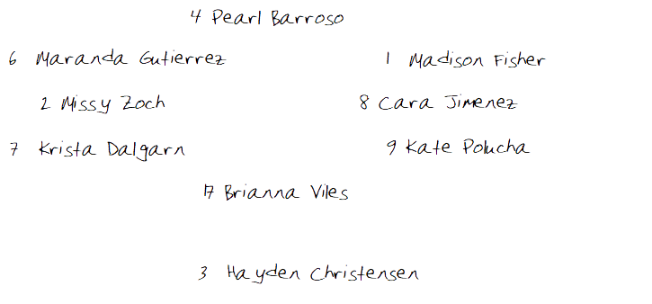
C

PITCHER

1B

3B

2B

SS

CF

RF

LF

Bottom of Inning (OFFENSE) |  |  |  | Tate University Warriors
BO | ## | PO | PLAYER |  | 1 | 2 | 3 | 4 | 5 | 6 | 7 | 8 | 9 | 10
1
2
3
4
5
6
7
 |  |  | 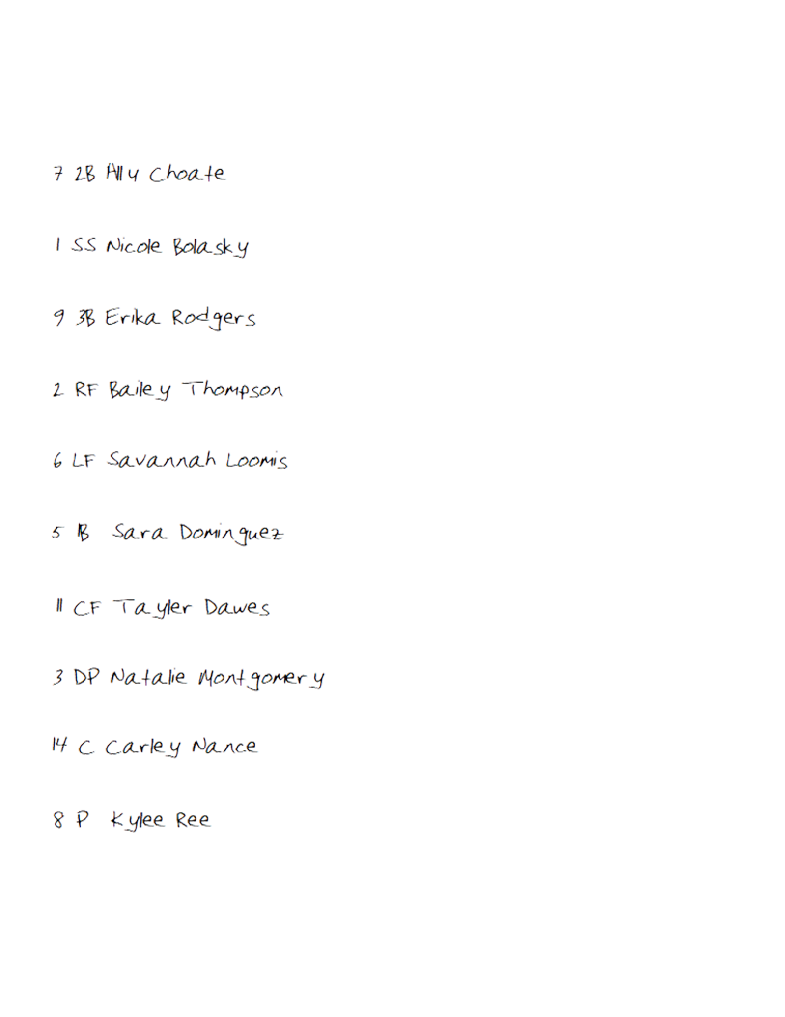
8
9
FLEX |  |  |  |  | Notes/Special

Game Notes:

