 |  |  |  |  | 1st |  | 2nd | 3rd |  | OT1 |  | OT2 |  |  | SO |  | TOTAL |  | TIMEOUTS  REGULATION |  | TIMEOUTS  OVERTIME
^{V} | Medfield College |  |  |  |  |  |  |  |  |  |  |  |  |  |  |  |  |  |  |  | 
^{H} | Tate University |  |  |  |  |  |  |  |  |  |  |  |  |  |  |  |  |  |  |  | 
GOALS
Medfield College Lions |  |  |  |  |  |  |  |  |  |  |  |  | Tate University Warriros
No |  | Per | Type | Scorer |  | Assists |  |  | TOG |  |  |  | No | Per |  | Type |  | Scorer |  | Assists |  | TOG
1 |  |  |  |  |  |  |  |  |  |  |  |  | 1
2 |  |  |  |  |  |  |  |  |  |  |  |  | 2
3 |  |  |  |  |  |  |  |  |  |  |  |  | 3
4 |  |  |  |  |  |  |  |  |  |  |  |  | 4
5 |  |  |  |  |  |  |  |  |  |  |  |  | 5
6 |  |  |  |  |  |  |  |  |  |  |  |  | 6
7 |  |  |  |  |  |  |  |  |  |  |  |  | 7
8 |  |  |  |  |  |  |  |  |  |  |  |  | 8
9 |  |  |  |  |  |  |  |  |  |  |  |  | 9
10 |  |  |  |  |  |  |  |  |  |  |  |  | 10
11 |  |  |  |  |  |  |  |  |  |  |  |  | 11
12 |  |  |  |  |  |  |  |  |  |  |  |  | 12
PENALTIES
Medfield College Lions |  |  |  |  |  |  |  |  |  |  |  |  | Tate University Warriros
No |  | Per | Player | Length |  | Type |  |  | TOP |  |  |  | No | Per |  | Player |  | Length |  | Type |  | TOP
1 |  |  |  |  |  |  |  |  |  |  |  |  | 1
2 |  |  |  |  |  |  |  |  |  |  |  |  | 2
3 |  |  |  |  |  |  |  |  |  |  |  |  | 3
4 |  |  |  |  |  |  |  |  |  |  |  |  | 4
5 |  |  |  |  |  |  |  |  |  |  |  |  | 5
6 |  |  |  |  |  |  |  |  |  |  |  |  | 6
7 |  |  |  |  |  |  |  |  |  |  |  |  | 7
8 |  |  |  |  |  |  |  |  |  |  |  |  | 8
9 |  |  |  |  |  |  |  |  |  |  |  |  | 9
10 |  |  |  |  |  |  |  |  |  |  |  |  | 10
11 |  |  |  |  |  |  |  |  |  |  |  |  | 11
12 |  |  |  |  |  |  |  |  |  |  |  |  | 12
13 |  |  |  |  |  |  |  |  |  |  |  |  | 13
14 |  |  |  |  |  |  |  |  |  |  |  |  | 14
15 |  |  |  |  |  |  |  |  |  |  |  |  | 15
16 |  |  |  |  |  |  |  |  |  |  |  |  | 16
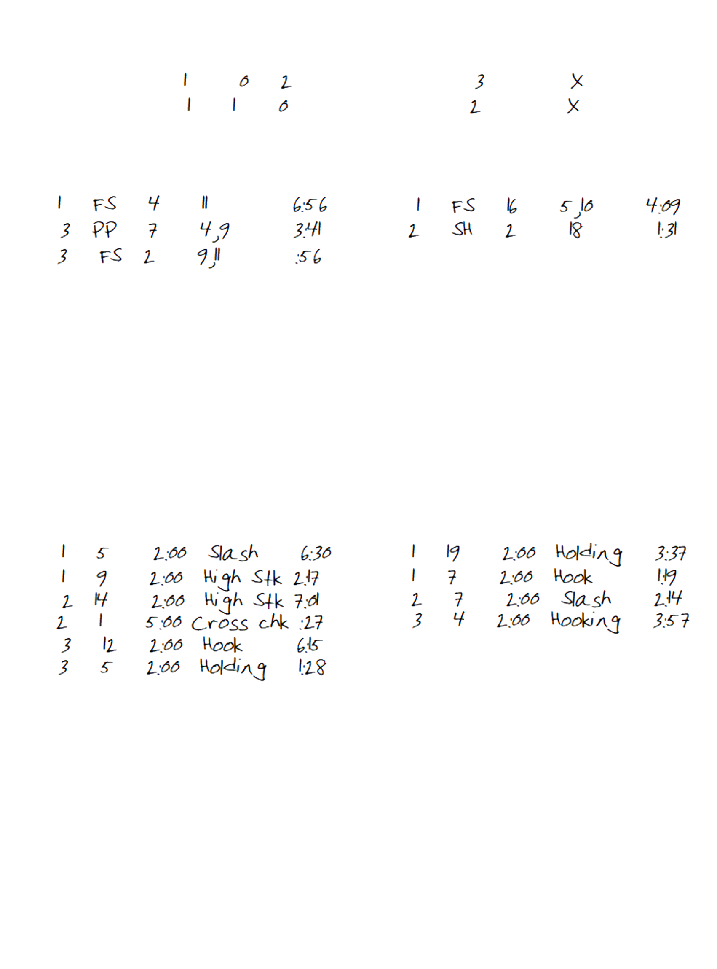
ROSTERS
Medfield College Lions |  |  | Tate University Warriors
## | PLAYER |  | ## | PLAYER
0 | Cam Welty |  | 00 | Austin Mitchell
1 | Trevor Peterson |  | 1 | Nicklas Rulle
2 | Fredy Mata |  | 2 | Rushoy Brown
3 | Juan Alejandre |  | 3 | Thomas M'Barek
4 | Josh Marquez |  | 4 | Vlad Jandric
5 | Jacob Penner |  | 5 | Antonio Burgoa
6 | Julio Varela |  | 6 | Zack Kluever
7 | Luis Lopez |  | 7 | Lawrence Karpeh
8 | Walmer Martinez |  | 8 | Stephen Milhoan
9 | Steve Lopez |  | 9 | Noah Pio
10 | Adrian Rebollar |  | 10 | Gianluca DiFranco
11 | Harry Barba |  | 11 | Ben Hryszko
12 | Rudy Pedroza |  | 14 | Jacob Lynn
14 | Pedro Hernandez |  | 15 | Jannis Schmidt
15 | Miles Ramos |  | 16 | Stjepan Mijic-Barisic
16 | Justin LaPerle |  | 17 | Hayden Parente
17 | Antonio Ordonez |  | 18 | Tommy Paltani
18 | Steven Moreno |  | 19 | Gabriel Pewu
19 | Adrian Ortiz |  | 20 | Saahb Kular
20 | Matthew Lee |  | 21 | Thomas Bielanski
21 | Luis Mendoza |  | 22 | Ivan Babic
23 | Jordan Sime |  | 23 | Colin Kane
24 | Raul Magos |  | 24 | Brandon George
25 | Robert Rodriguez |  | 25 | Keagan Brown
26 | Brad Moorehouse |  | 30 | Dan Manolache
27 | George Gonzalez |  | 31 | Ryan Kolonick
28 | Tanner Ruddy |  | 32 | Skylar Jeppesen

