 |  |  |  |  | 1 | 2 | 3 | 4 | 5 |  |  | 6^{LL} |  |  | 7^{HS} |  | 8 | 9 | 10 | 11 | 12 | TOTAL
^{V} | Medfield College |  |  |  |  |  |  |  | 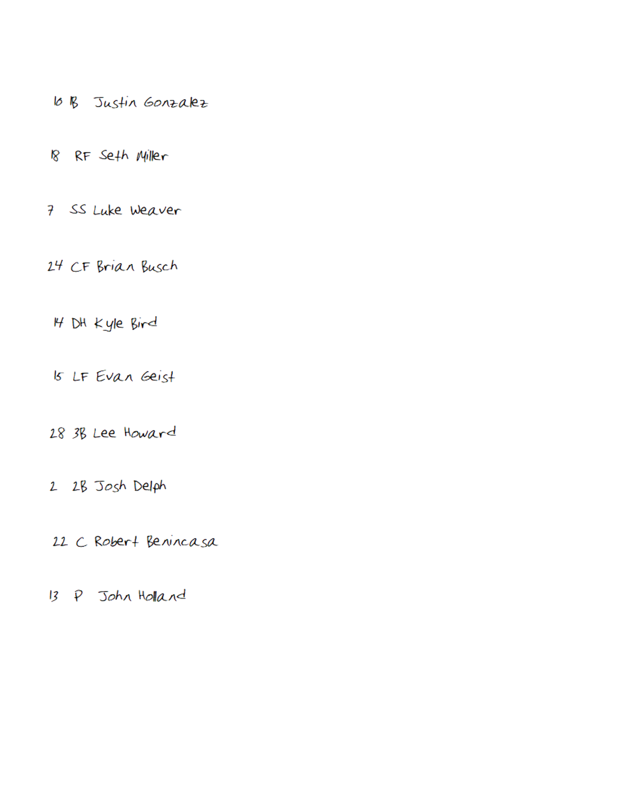
^{H} | Tate University
Medfield College Lions |  |  |  |  |  |  |  |  |  |  | Tate University Warriors
BO |  | ## | PO | PLAYER |  |  |  |  |  |  | BO |  | ## | PO |  | PLAYER
1 |  |  |  | 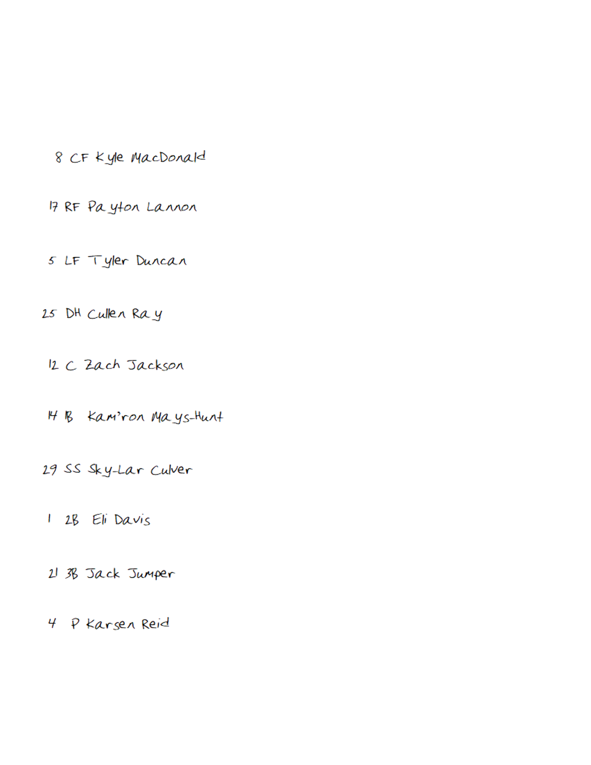 |  |  |  |  |  |  | 1
2 |  |  |  |  |  |  |  |  |  |  | 2
3 |  |  |  |  |  |  |  |  |  |  | 3
4 |  |  |  |  |  |  |  |  |  |  | 4
5 |  |  |  |  |  |  |  |  |  |  | 5
6 |  |  |  |  |  |  |  |  |  |  | 6
7 |  |  |  |  |  |  |  |  |  |  | 7
8 |  |  |  |  |  |  |  |  |  |  | 8
9 |  |  |  |  |  |  |  |  |  |  | 9
Pitchers/Reserves |  |  |  |  |  |  |  |  |  |  | Pitchers/Reserves

