 |  |  |  | 1 | 2 | 3 | 4 |  | 5 |  | 6^{LL} |  | 7^{HS} |  | 8 |  | 9 |  | 10 |  | 11 |  | 12 |  | TOTAL
^{V} | Medfield College
^{H} | Tate University
Top of Inning (VISITORS) |  |  |  | Medfield College Lions
BO | ## | PO | PLAYER |  |  |  |  | 1 |  | 2 |  | 3 | 4 | 5 |  | 6 |  | 7 |  | 8 |  | 9 | 10 | 11 |  | 12
1
2
3
4
5
6 |  |  | 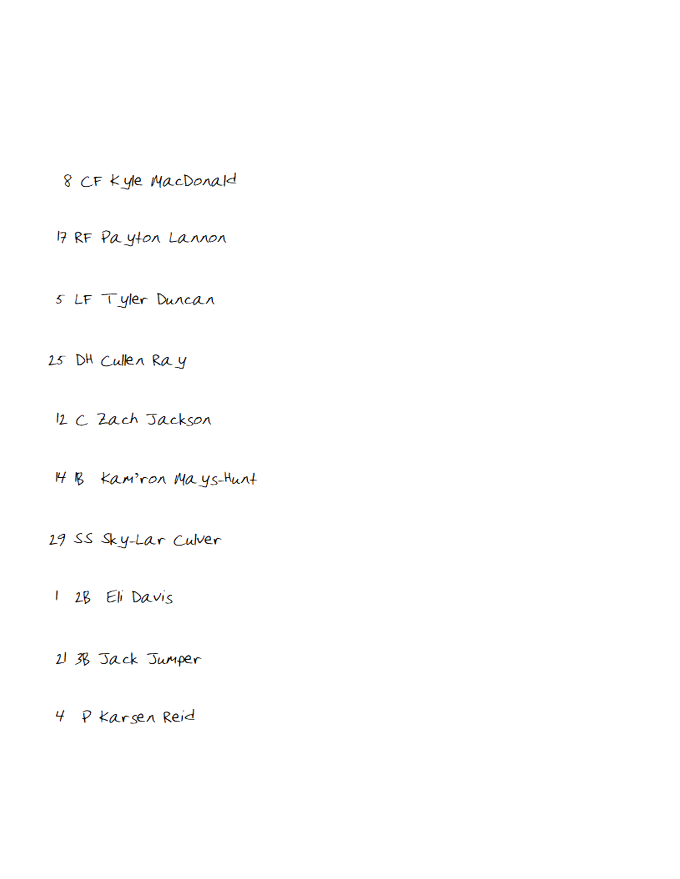
7
8
9
Pitcher/Reserves |  |  |  |  |  |  |  | Notes/Special

Bottom of Inning (HOME) |  |  |  | Tate University Warriors
BO | ## | PO | PLAYER |  | 1 | 2 | 3 | 4 | 5 | 6 | 7 | 8 | 9 | 10 | 11 | 12
1 |  |  | 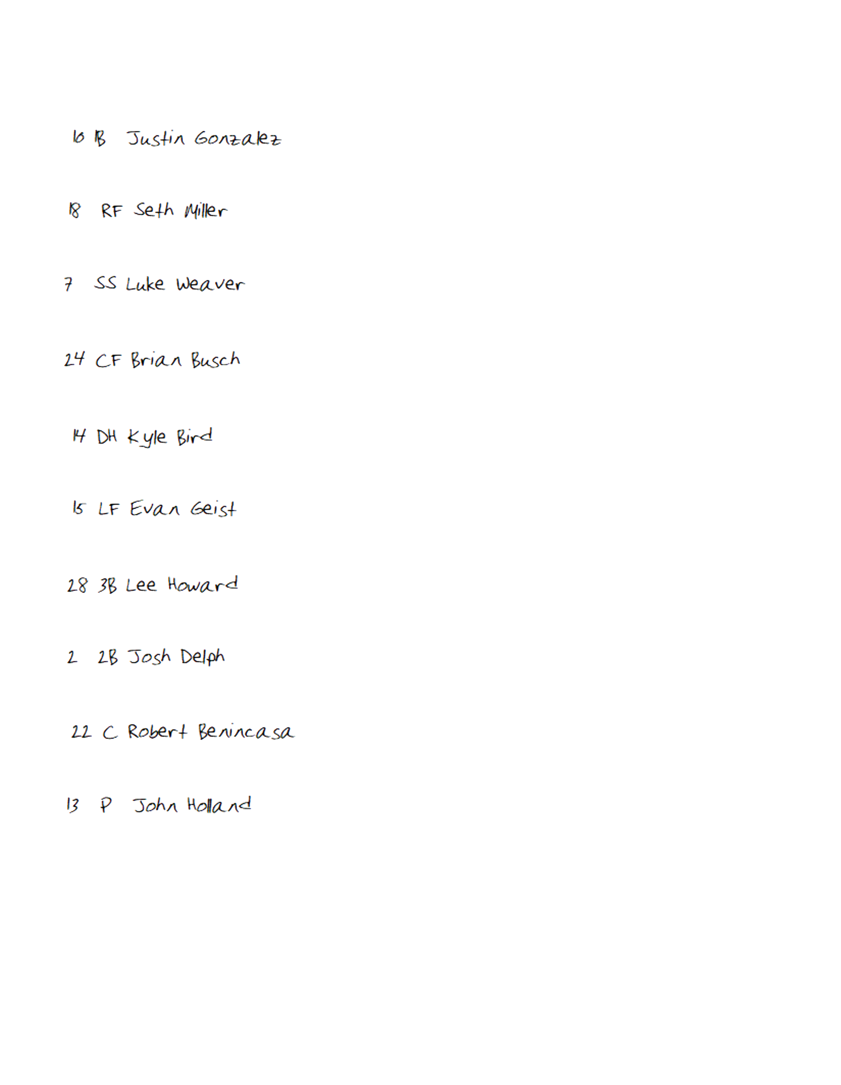
2
3
4
5
6
7
8
9
Pitcher/Reserves |  |  |  |  | Notes/Special
Game Notes:

