 |  | 1 | 2 | 3 | 4 | 5 | 6^{LL} | 7^{HS} | 8 | 9 | 10 | 11 | 12 | TOTAL
^{V} | Medfield College
^{H} | Tate University
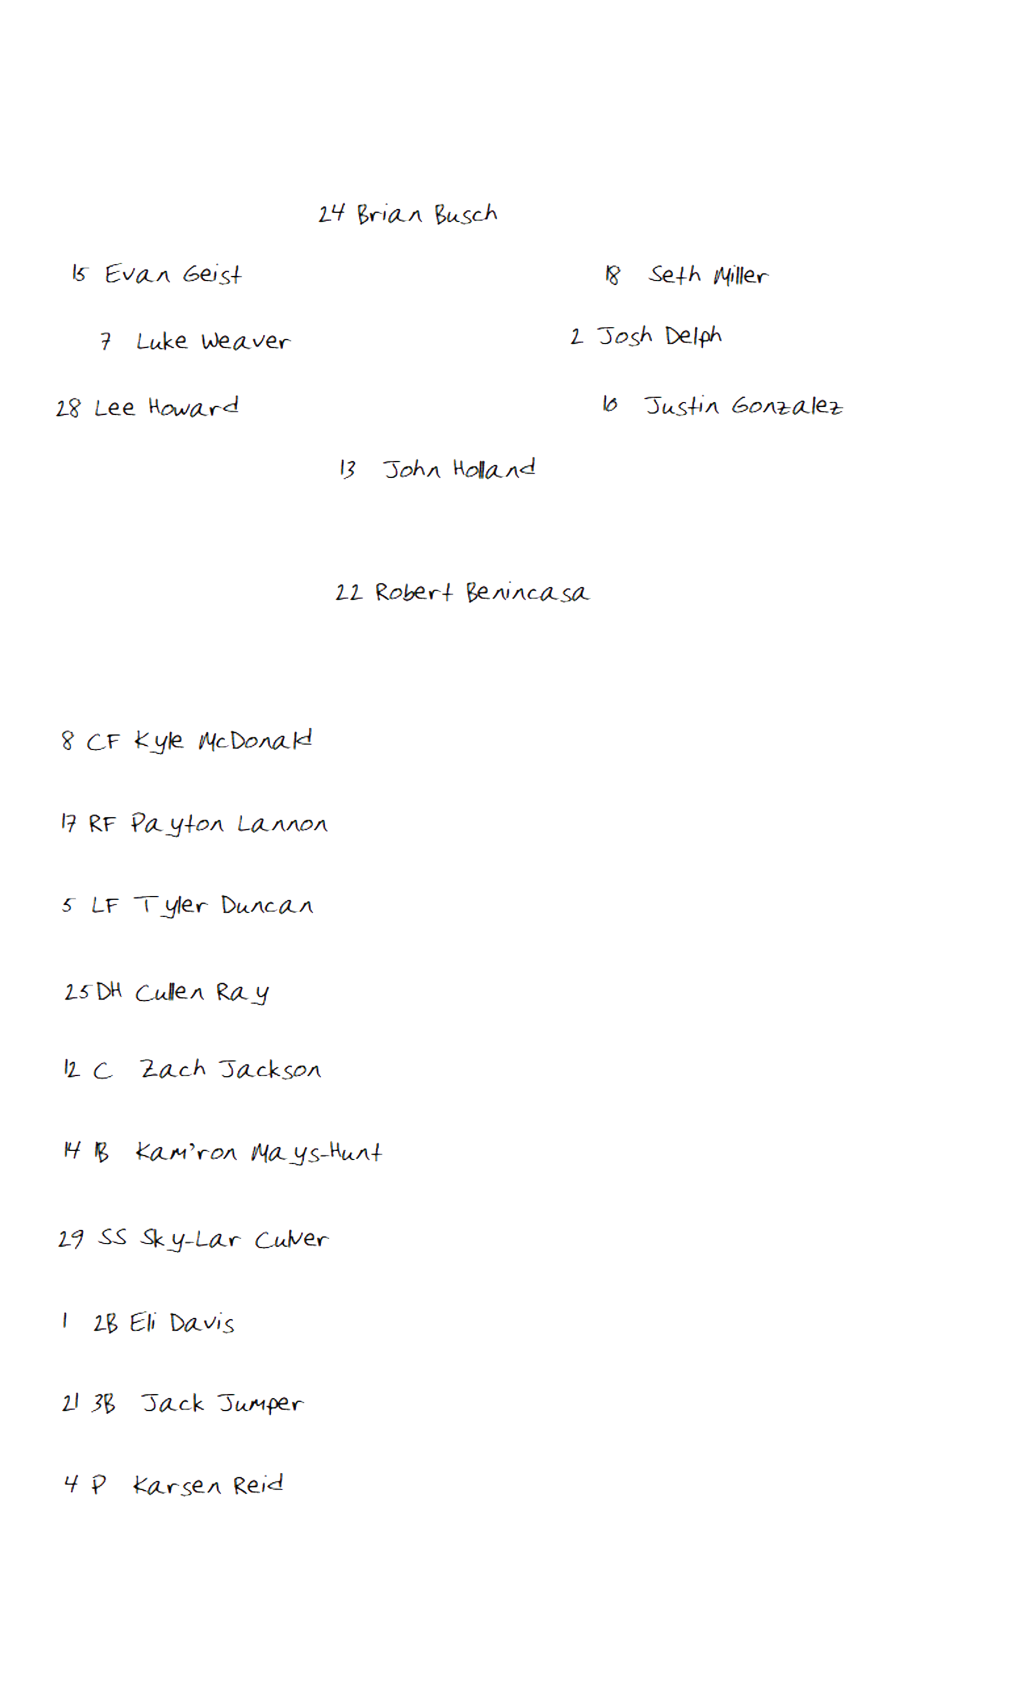
CF

Top of Inning (DEFENSE) | Tate University

Top of Inning (OFFENSE) |  |  |  | Medfield College
BO | ## | PO | PLAYER |  | 1 | 2 | 3 | 4 | 5 | 6^{LL} | 7^{HS} | 8 | 9 | 10 | 11 | 12
1
2
3
4
5
6
7
8
9
Pitchers/Reserves |  |  |  |  | Notes/Special
C

PITCHER

1B

3B

2B

SS

LF

RF

Bottom of Inning (DEFENSE) | Medfield College
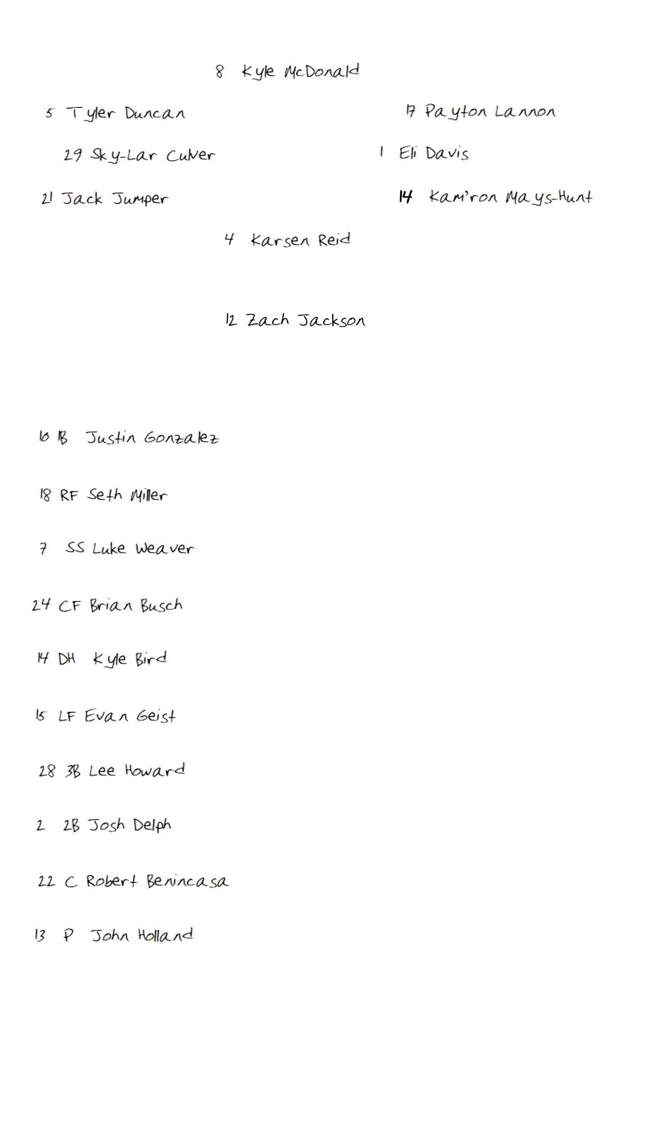
C

PITCHER

1B

3B

2B

SS

CF

RF

LF

Bottom of Inning (OFFENSE) |  |  |  | Tate University
BO | ## | PO | PLAYER |  | 1 | 2 | 3 | 4 | 5 | 6^{LL} | 7^{HS} | 8 | 9 | 10 | 11 | 12
1
2
3
4
5
6
7
8
9
Pitchers/Reserves |  |  |  |  | Notes/Special

Game Notes:

